1# Check X11 forwarding is enabled:  
As root:  
root# vi /etc/ssh/sshd_config

X11Forwarding yes “if it is ‘no’ change it to ‘yes’ and save the file”

root# systemctl restart sshd

2# Login as “oracle” to any VM:

ssh [oracle@10.10.160.116](mailto:oracle@10.10.160.116)

3# Run any bash profile from /home/oracle :

oracle# . ACX9PRD

oracle# dbca  
  
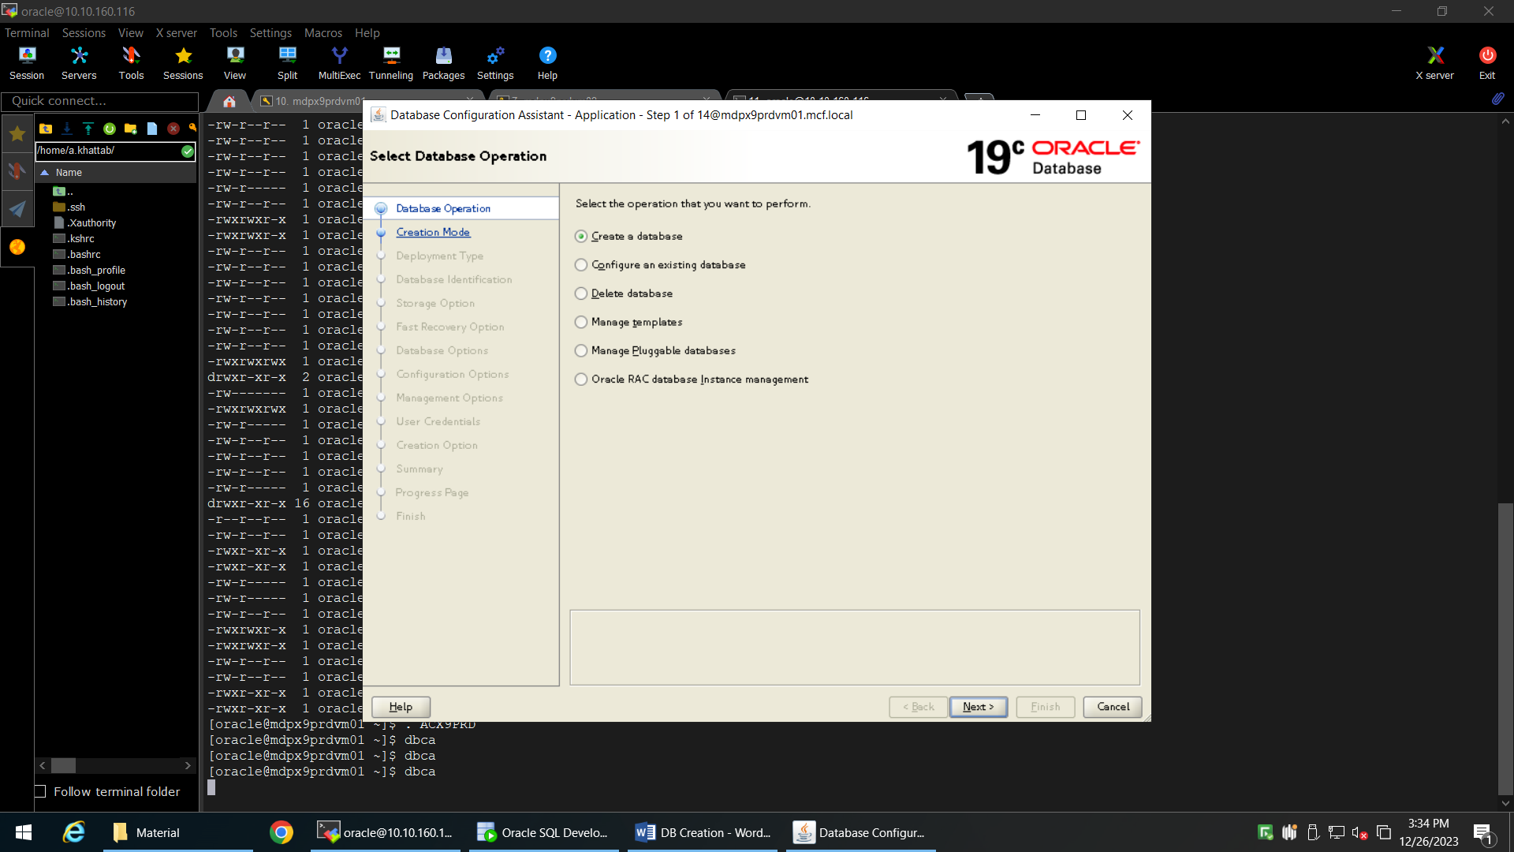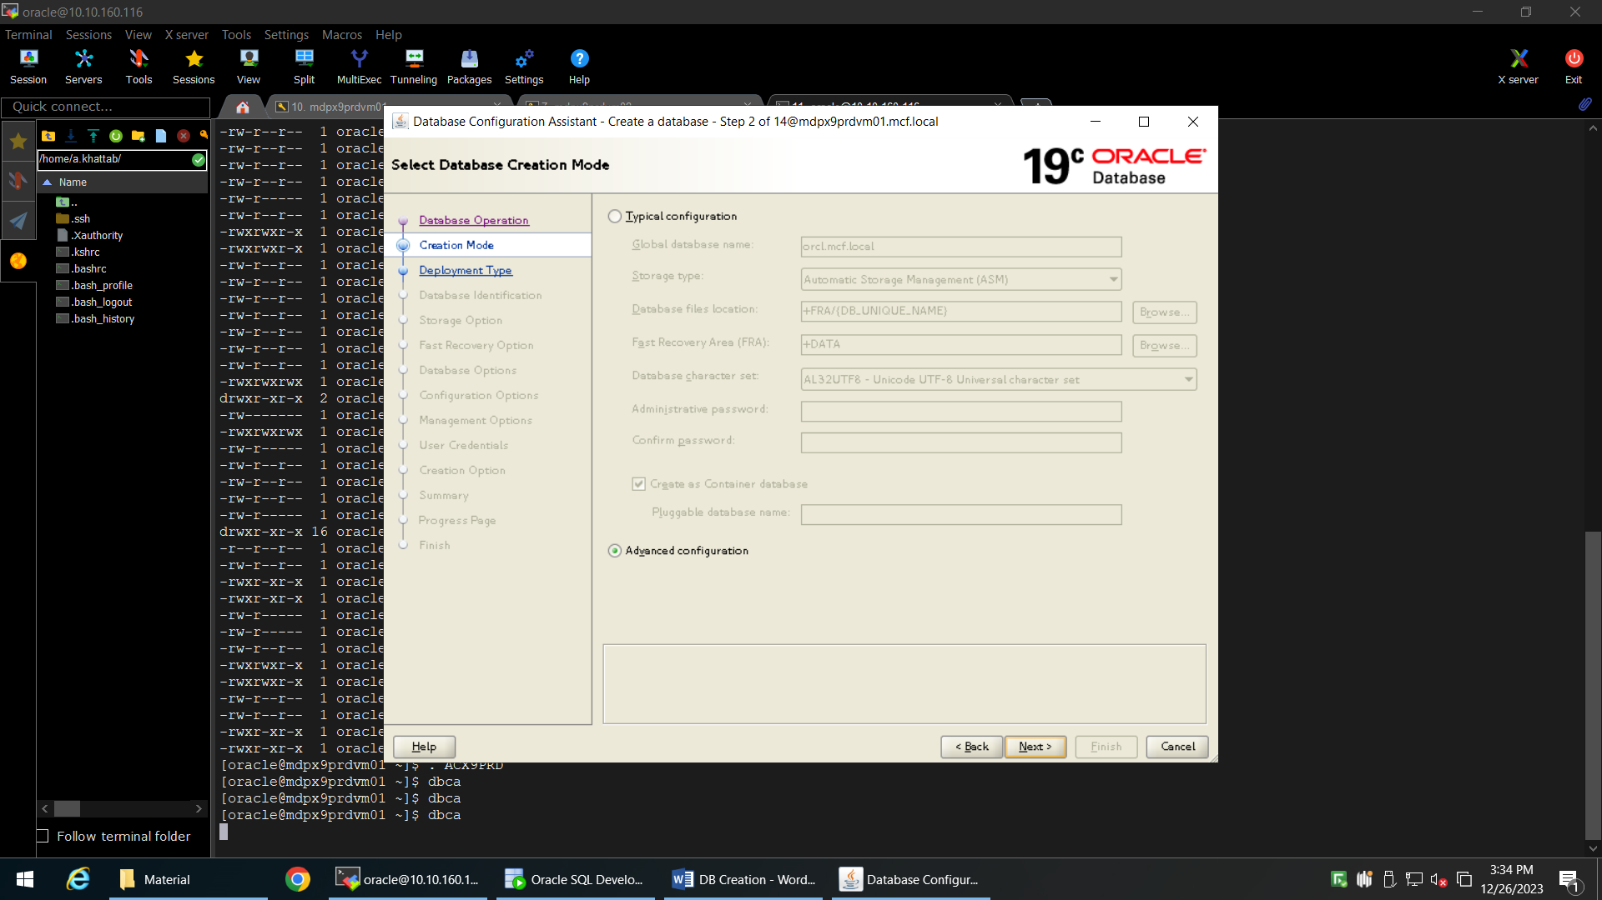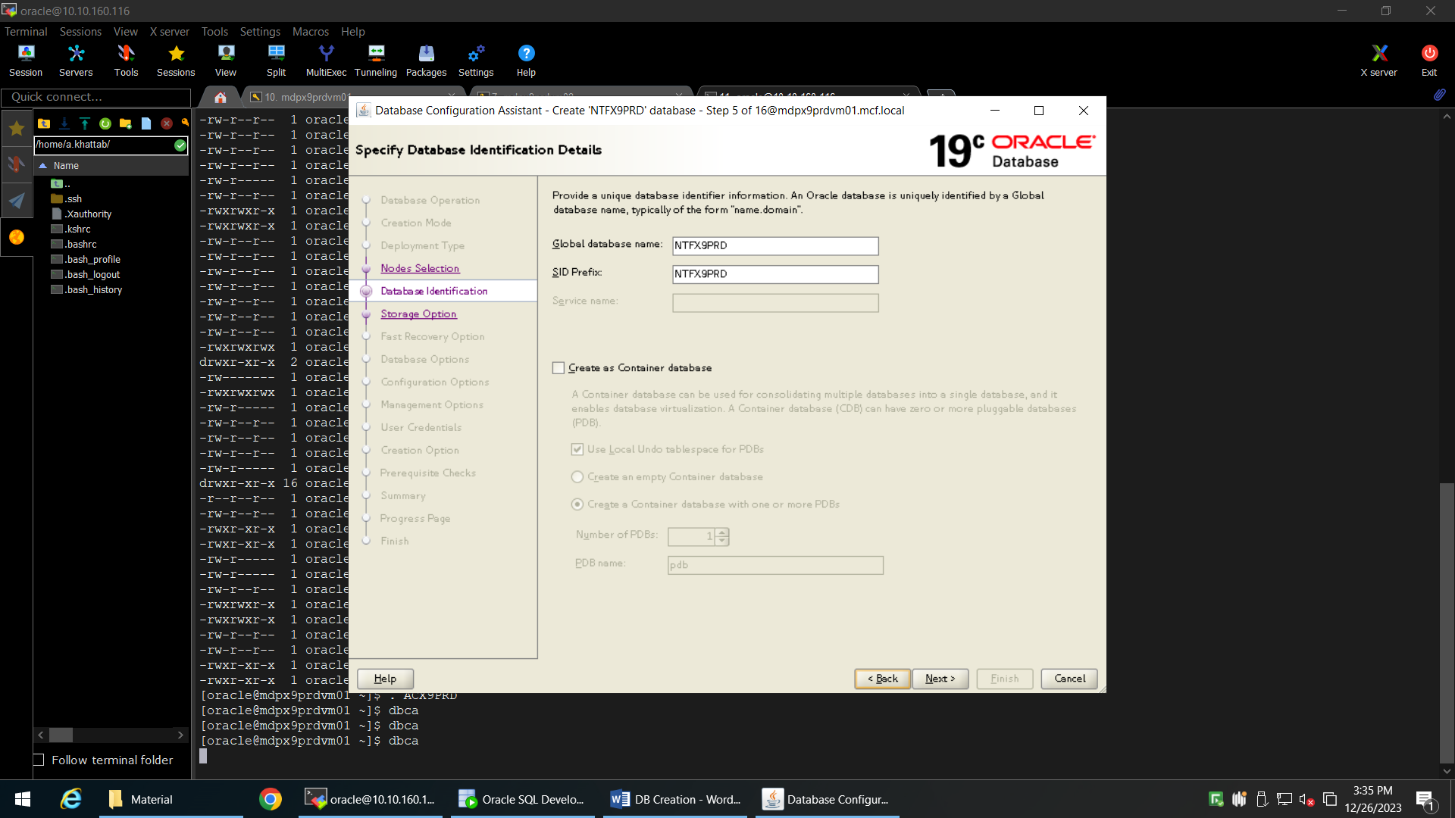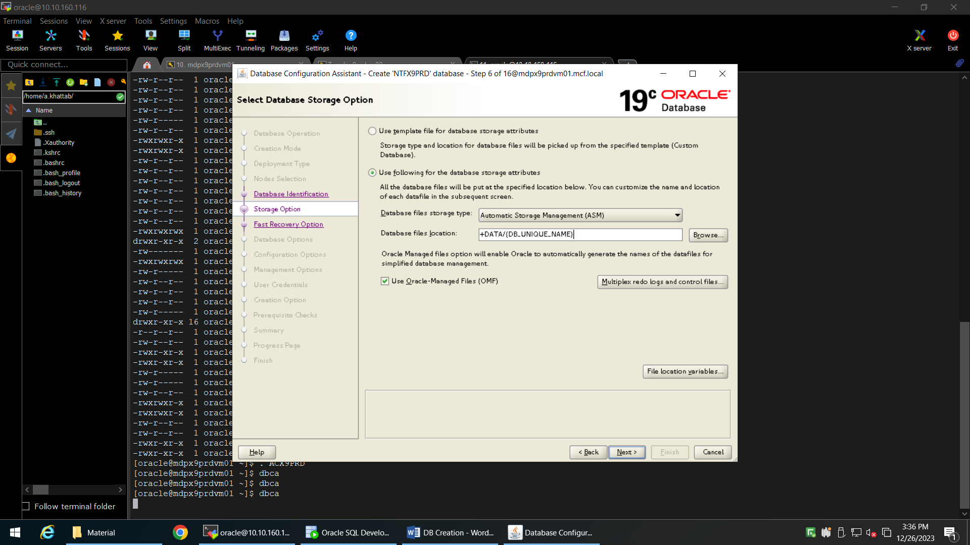

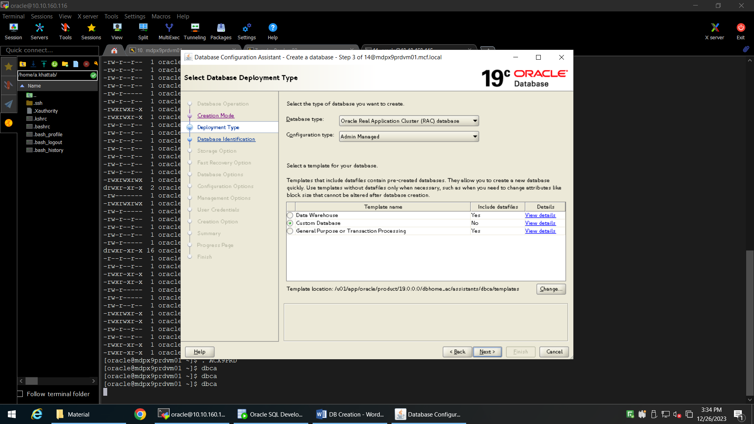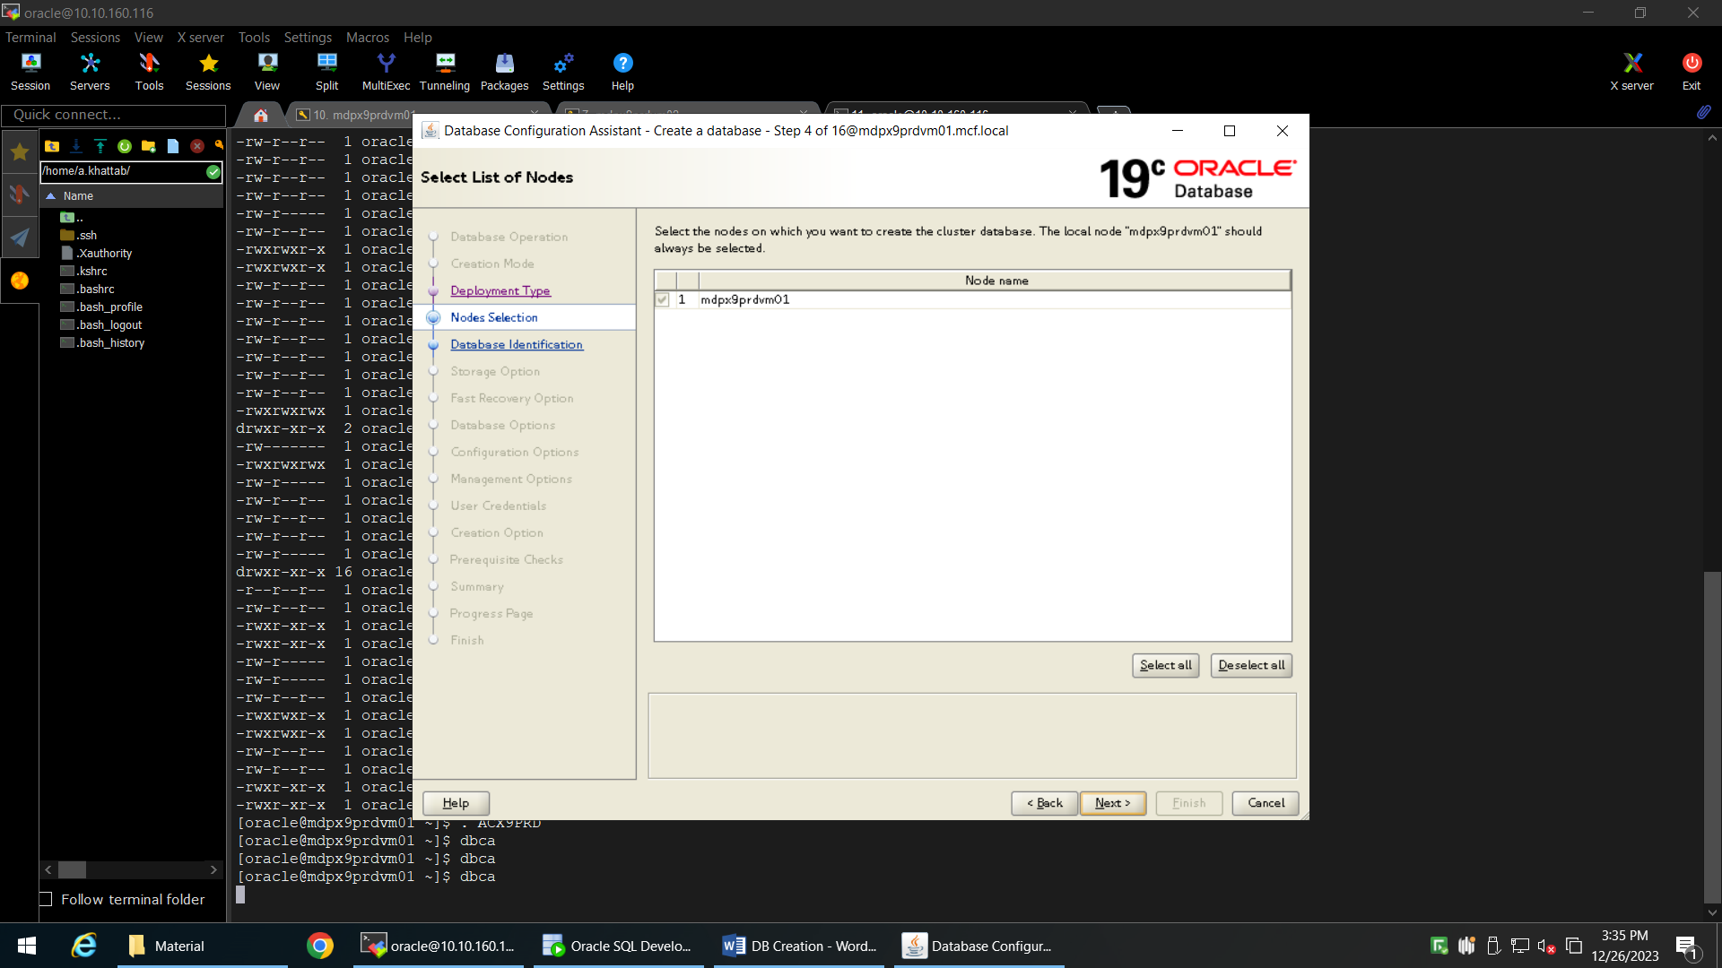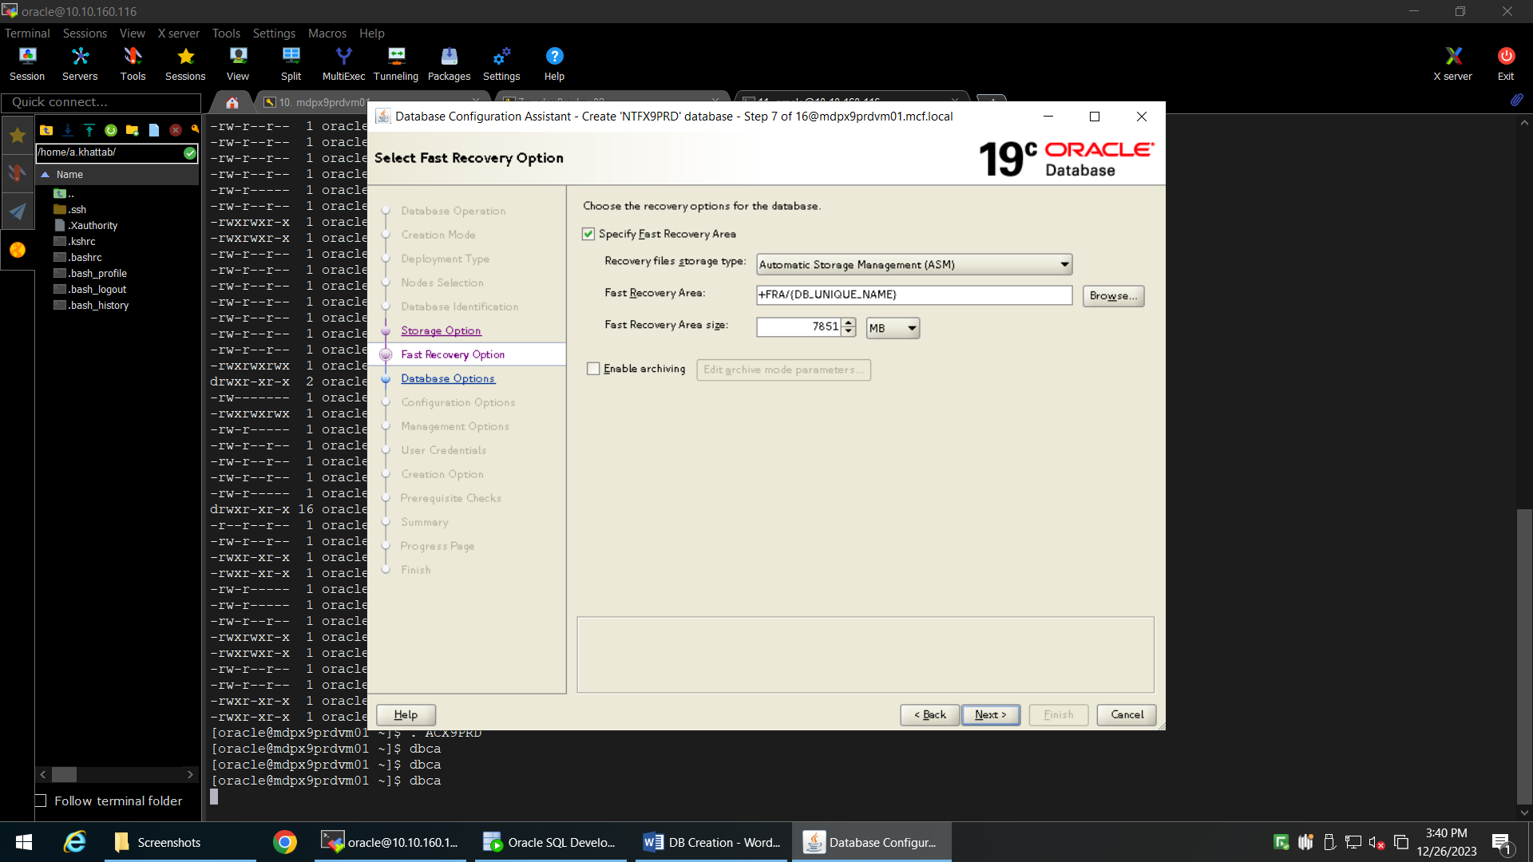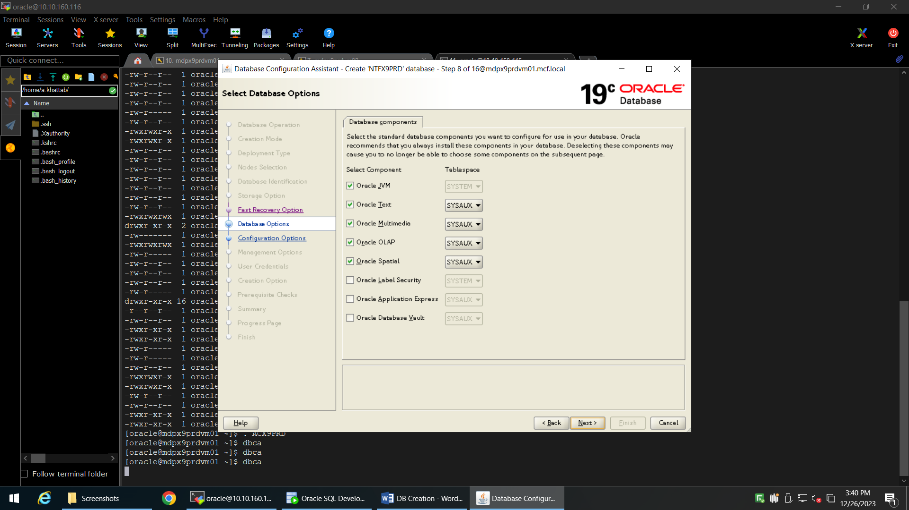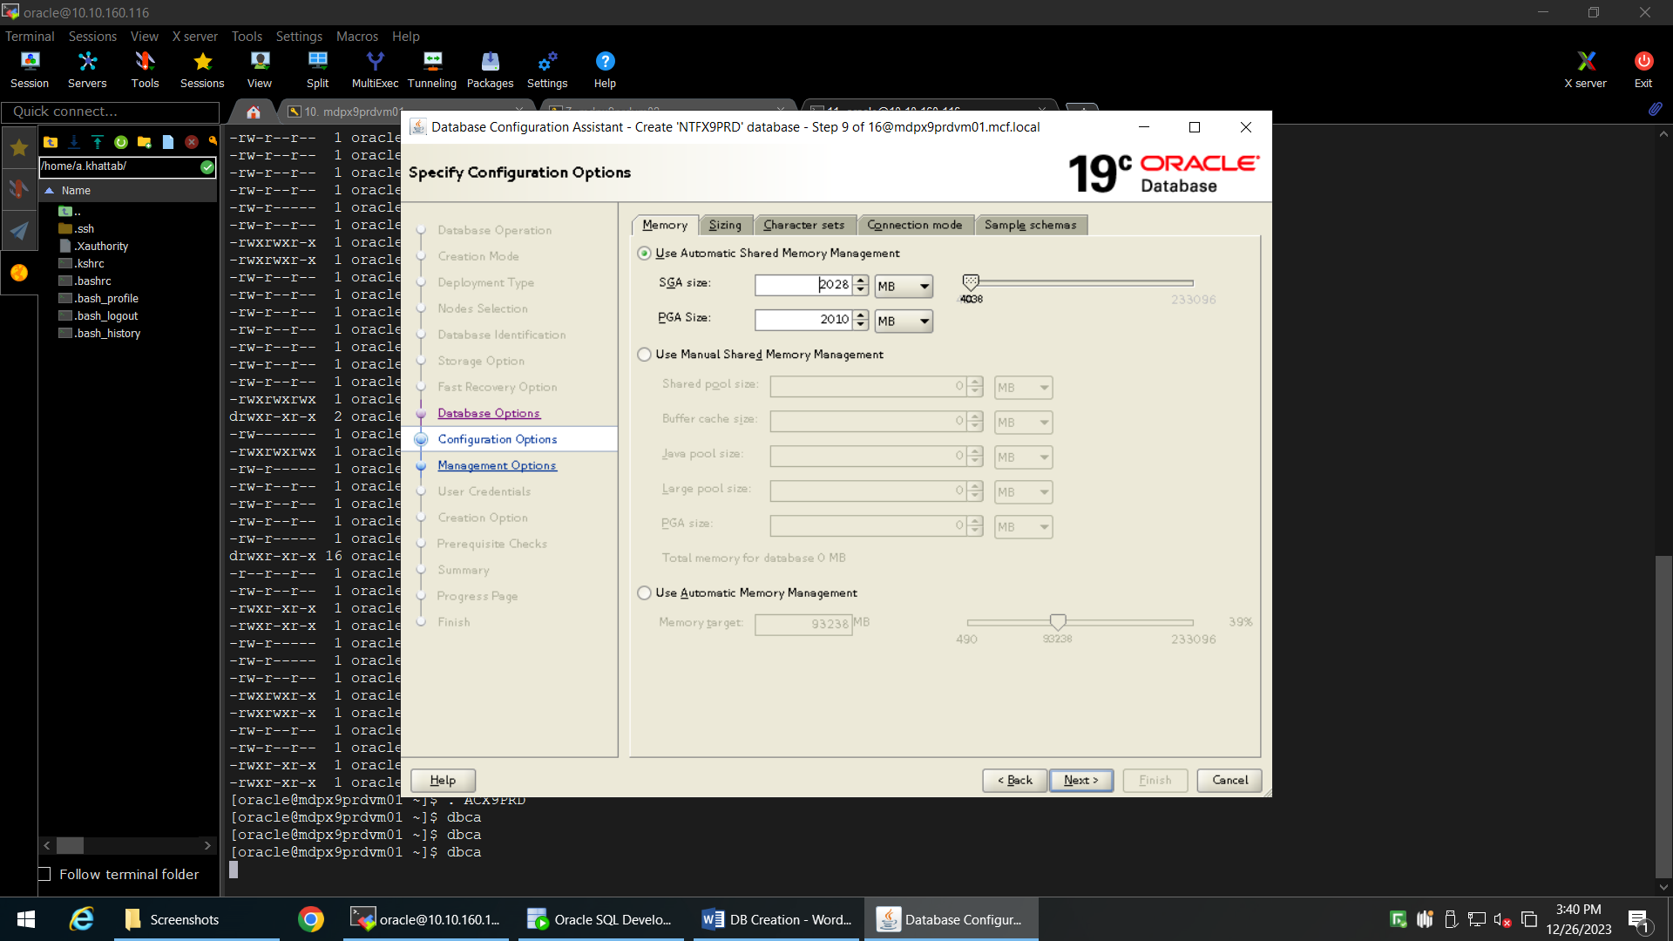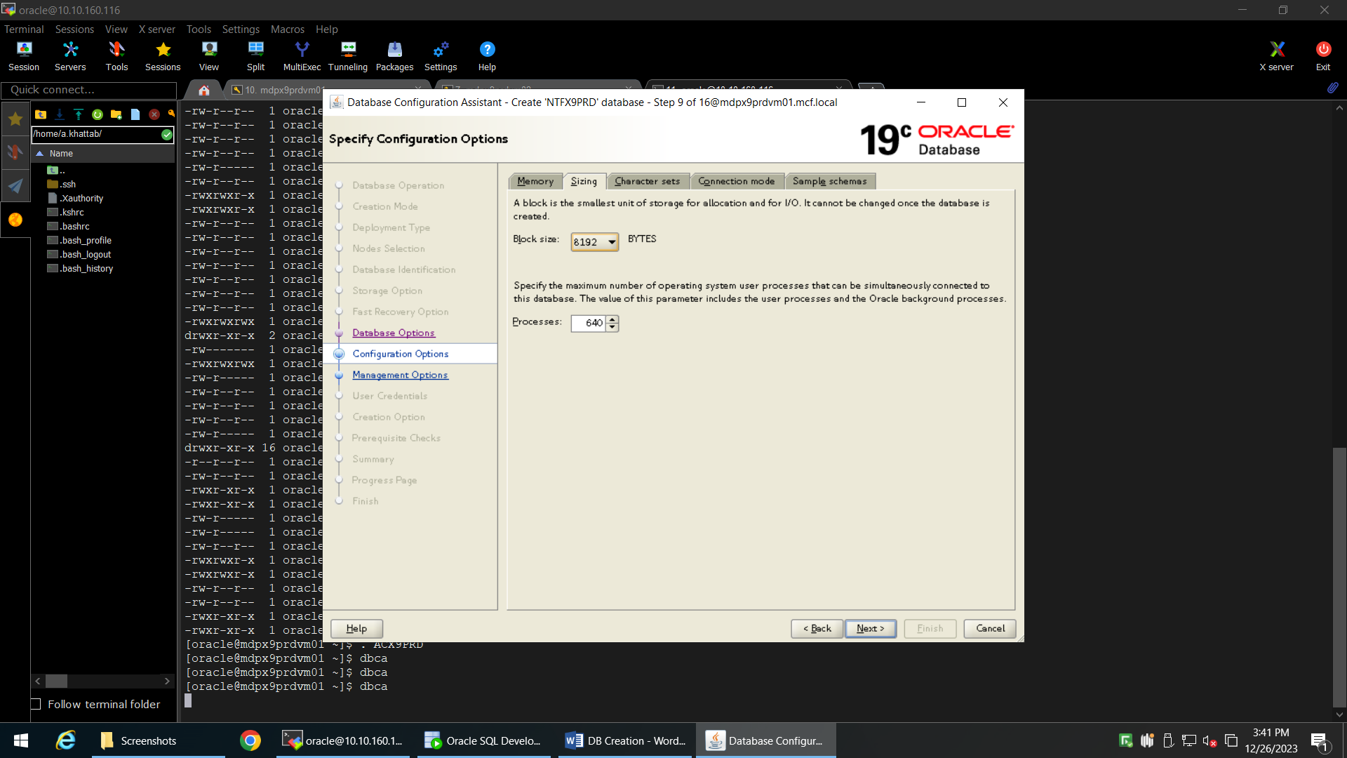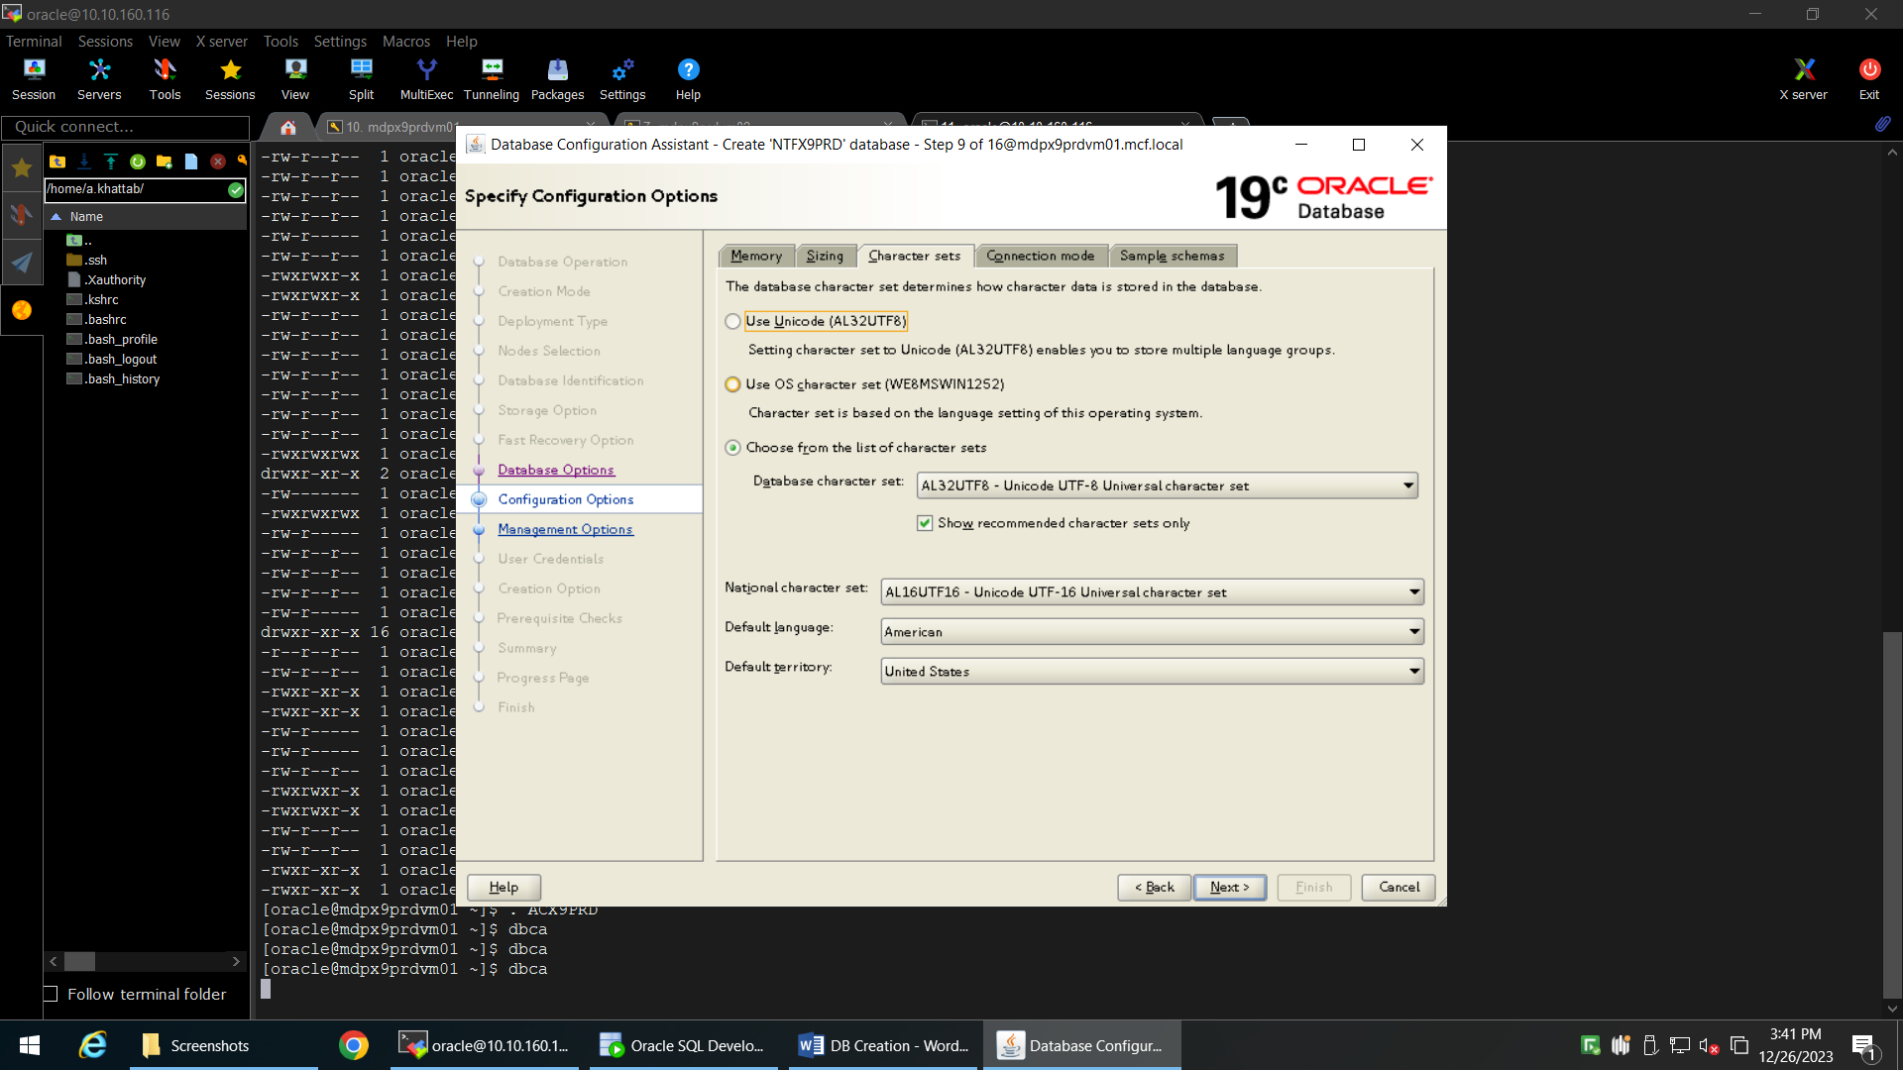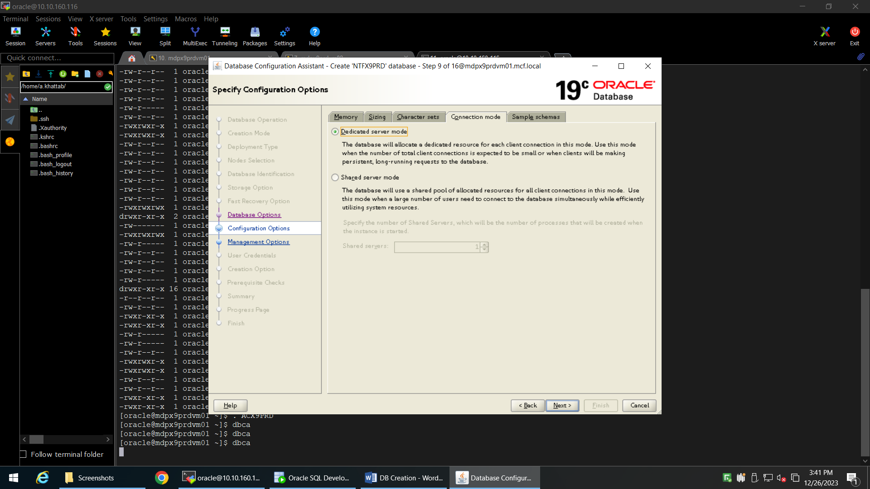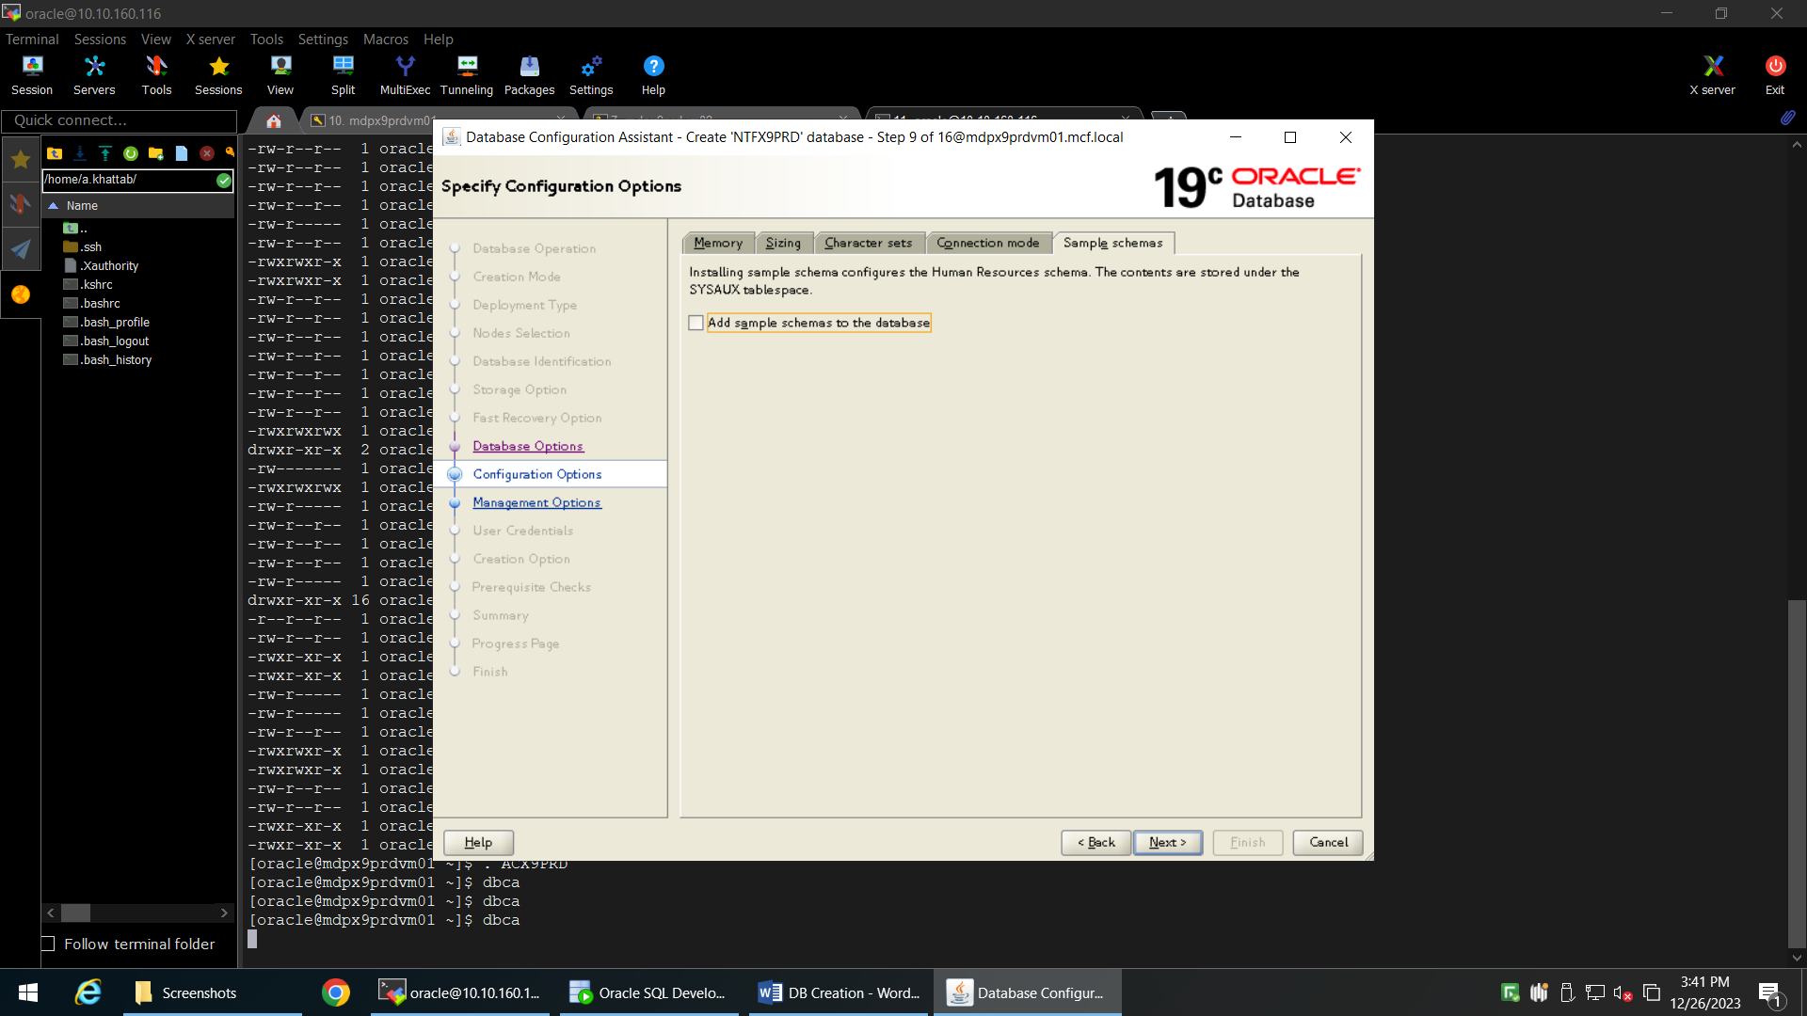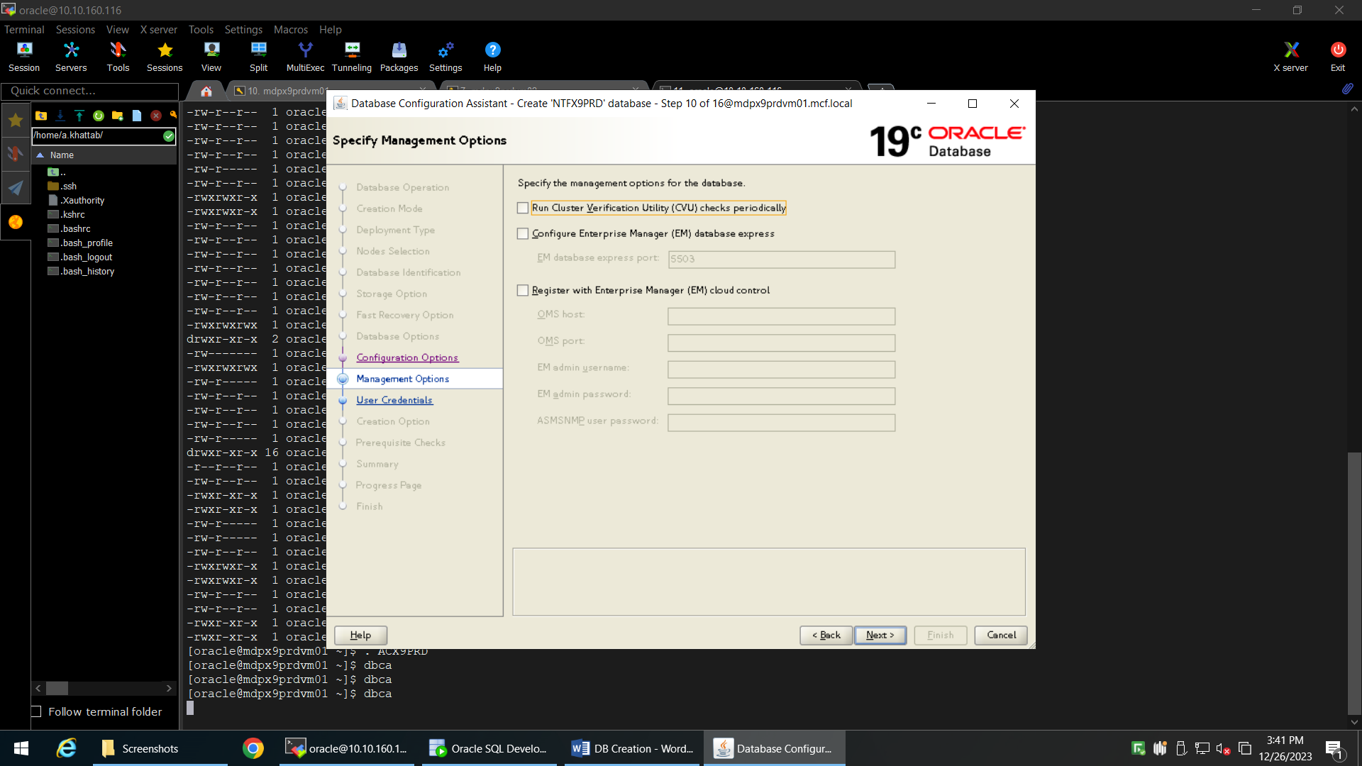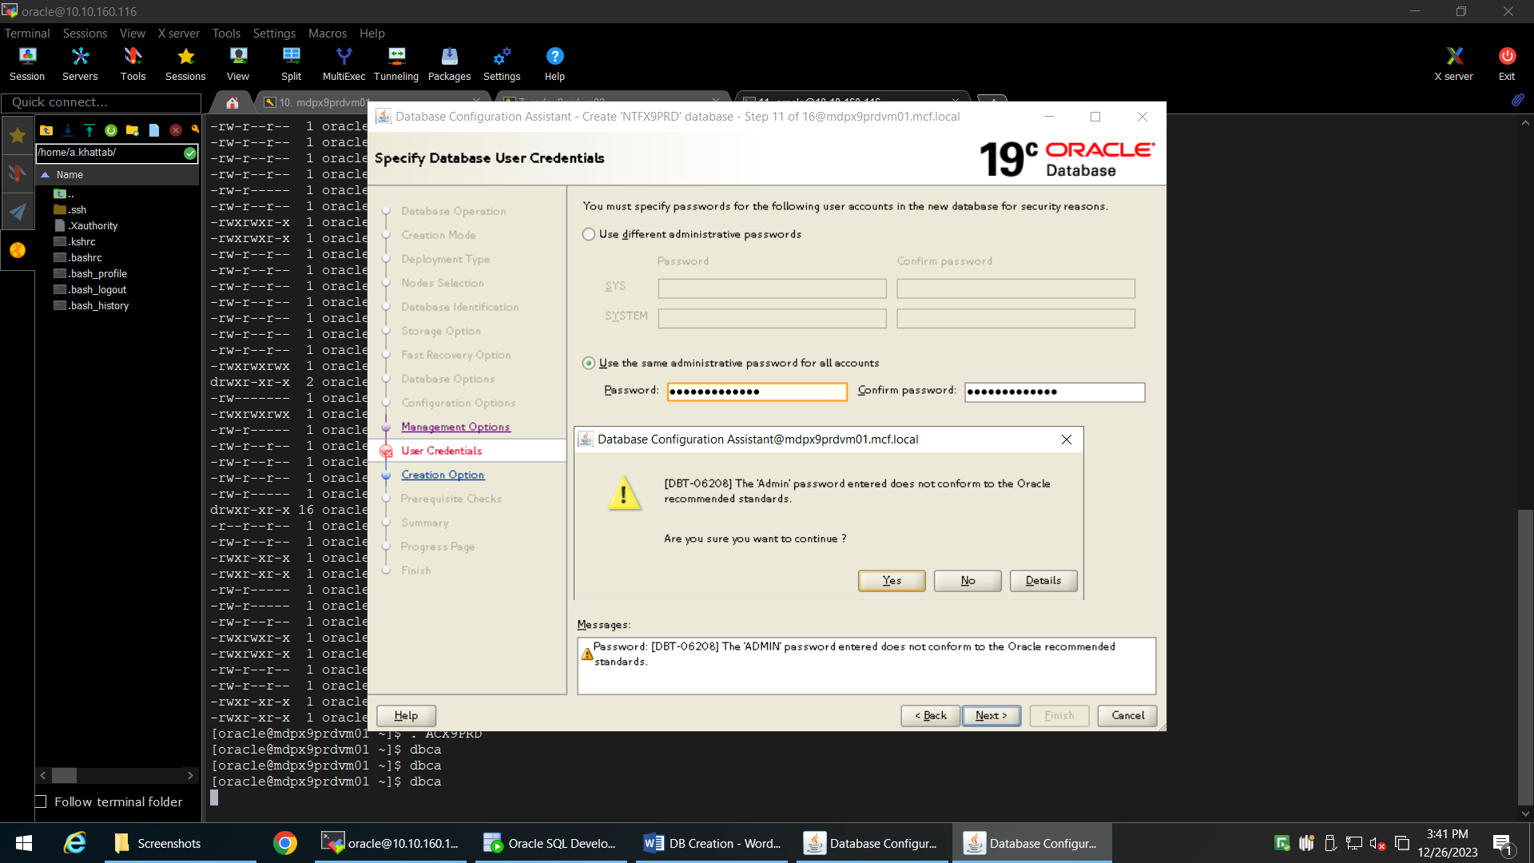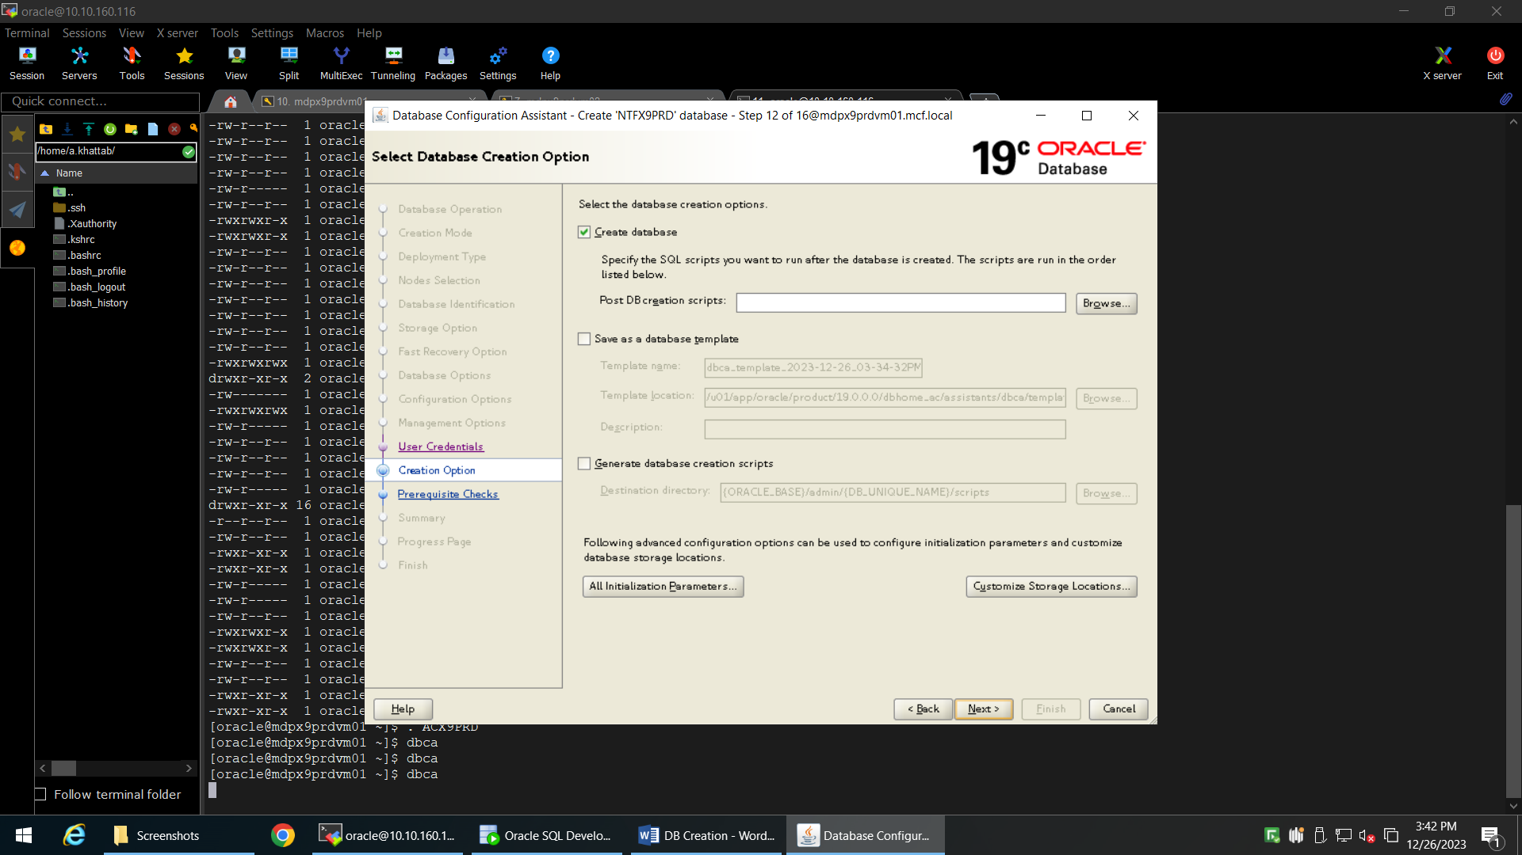

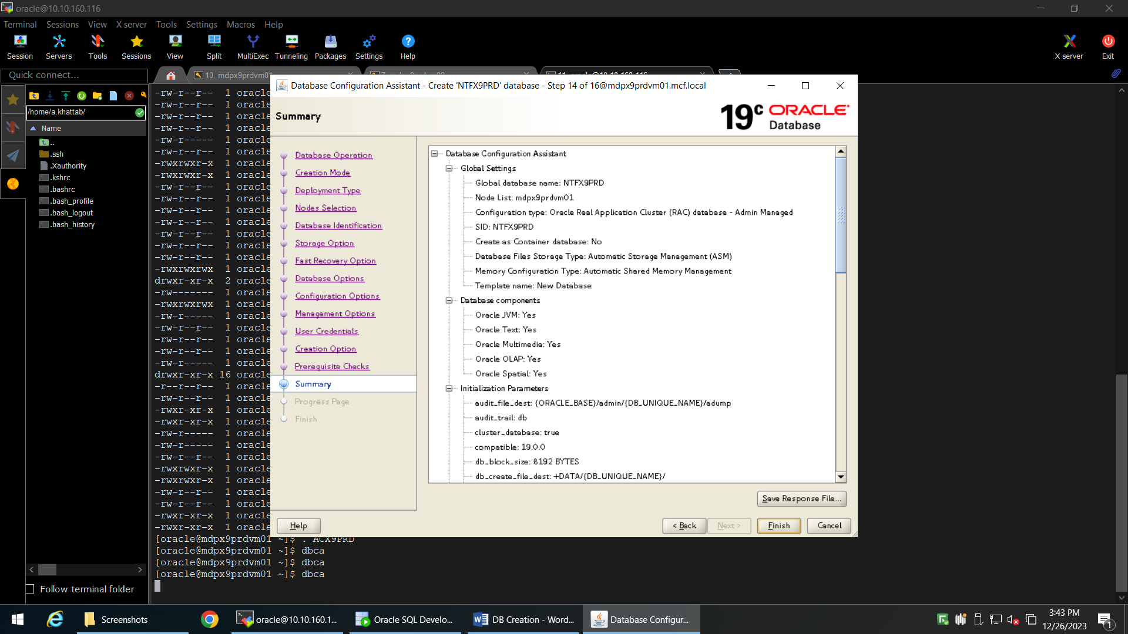

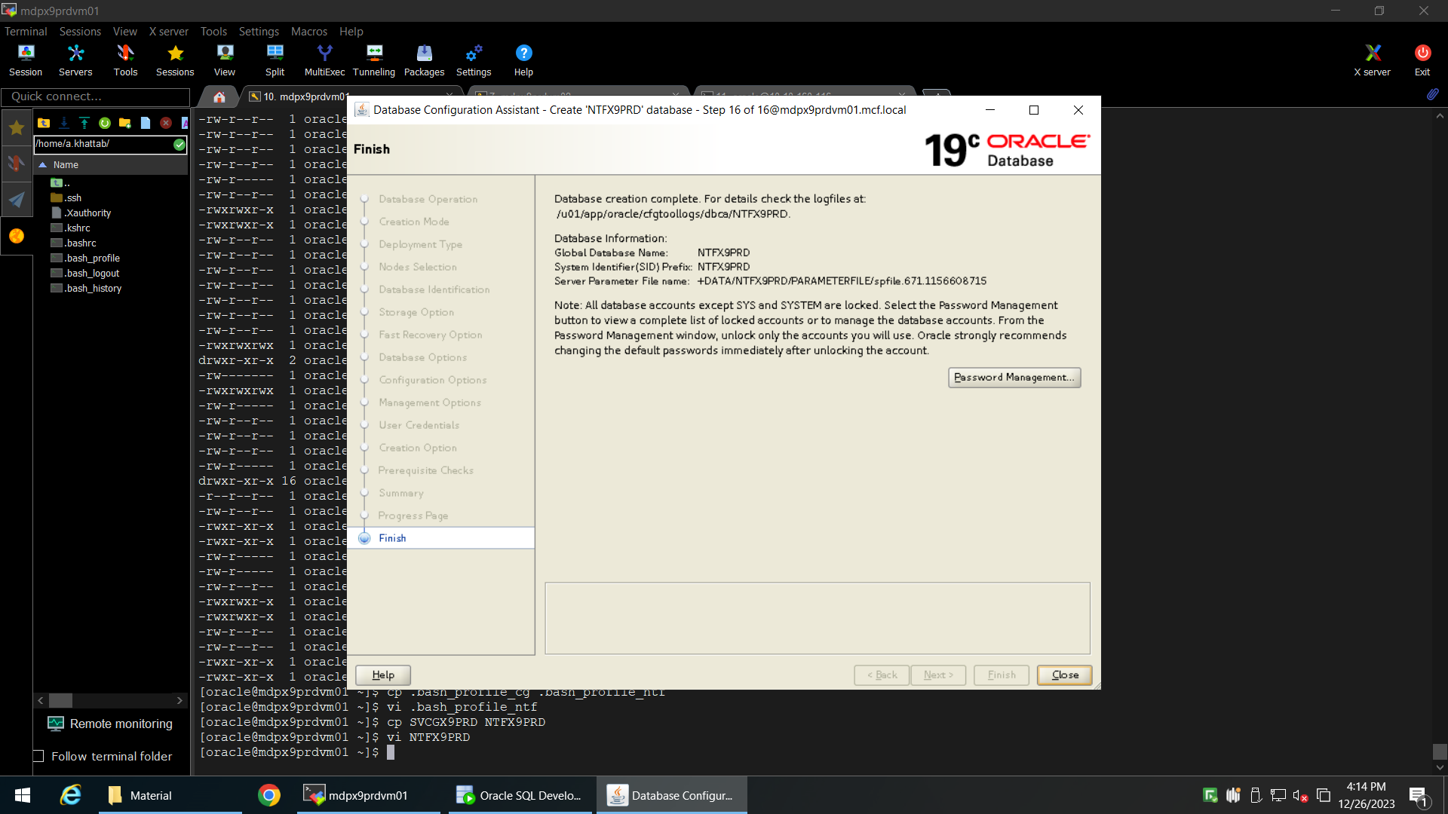

4# Create bash profile for the new DB:

oracle# cp .bash_profile_cg .bash_profile_ntf  
oracle# vi .bash_profile_ntf  
- change ‘ORACLE_SID’ to the new one ‘NTFX9PRD1’ or ‘NTFX9PRD2’ if you are on node 2.  
- make sure the ‘ORACLE_HOME’ is right

oracle# cp SVCGX9PRD NTFX9PRD  
oracle# vi NTFX9PRD  
- change the bash profile name to the new one ‘. .bash_profile_ntf’

5# Run bash profile

oracle# . NTFX9PRD  
oracle# echo $ORACLE_SID

6# Check the database configuration:

oracle# srvctl config database –d NTFX9PRD

- make sure that the database instance name is the same as $ORACLE_SID

7# Connect to DB  
oracle# sqlplus / as sysdba

8# Create instance for node 2:

oracle# srvctl add instance -d NTFX9PRD -i NTFX9PRD2 -n mdpx9prdvm02

9# Create bash profile on node 2 “repeat steps 4,5,6,7”

10# To start the DB you need to modify parameter ‘instance_number’ on the spfile:  
oracle# sqlplus / as sysdba  
SQL> create pfile ='/u01/app/oracle/product/19.0.0.0/dbhome_ac/dbs/initNTFX9PRD2.ora' from spfile='+DATA/NTFX9PRD/PARAMETERFILE/spfile.671.1156608715';  
SQL> !vi /u01/app/oracle/product/19.0.0.0/dbhome_ac/dbs/initNTFX9PRD2.ora

- Add the following parameters:  
NTFX9PRD2.instance_number=2  
NTFX9PRD2.thread=2

NTFX9PRD1.undo_tablespace='UNDOTBS1'

NTFX9PRD2.undo_tablespace='UNDOTBS2'

- Change the first parameters instance from ‘NTFX9PRD1’ to ‘*’  
- Save the file and create new spfile:  
SQL> create spfile='+DATA/NTFX9PRD/PARAMETERFILE/spfile.671.1156608715.ora' from pfile ='/u01/app/oracle/product/19.0.0.0/dbhome_ac/dbs/initNTFX9PRD2.ora';

SQL> !cp /u01/app/oracle/product/19.0.0.0/dbhome_ac/dbs/initNTFX9PRD2.ora /u01/app/oracle/product/19.0.0.0/dbhome_ac/dbs/initNTFX9PRD2.ora_bkp

SQL> !vi /u01/app/oracle/product/19.0.0.0/dbhome_ac/dbs/initNTFX9PRD2.ora

- Remove the content of the file and add the path of spfile:  
spfile=’+DATA/NTFX9PRD/PARAMETERFILE/spfile.671.1156608715.ora’

SQL> startup

SQL> show parameter spfile